**Network Fundamentals Week 4 Log Book**

**Summary**

In this weeks’ practical we created a bus topology network and simulated the operation of an Ethernet network.

**Implementation**

Following the instructions in the worksheet we created a rapid configuration bus network with 30 nodes all connected to one Ethernet cable. We then created different scenarios that used different inter arrival times.   
Scenario name: Coax2- Interarrival time attribute: Exponential (0.5) Save your project

Scenario name: Coax3- Interarrival time attribute: Exponential (0.25) Save your project

Scenario name: Coax4- Interarrival time attribute: Exponential (0.1) Save your project

Scenario name: Coax5- Interarrival time attribute: Exponential (0.05) Save your project

Scenario name: Coax6- Interarrival time attribute: Exponential (0.035) Save your project

Scenario name: Coax7- Interarrival time attribute: Exponential (0.03) Save your project

Scenario name: Coax8- Interarrival time attribute: Exponential (0.02) Save your project

After adding these different scenarios we then ran simulations for each one and outputted the results to a single graph.

**Results**

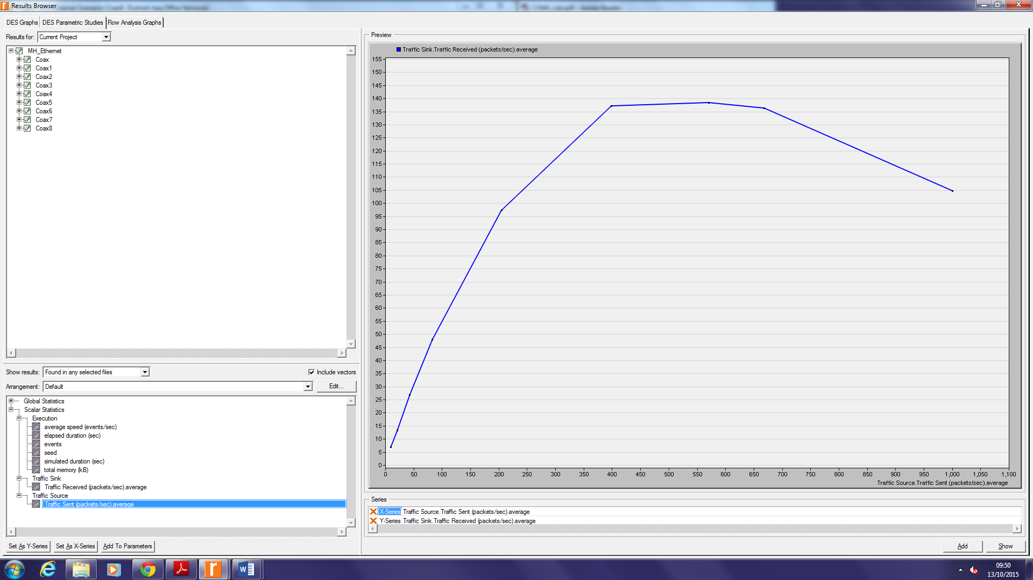

**Questions**

**Question**

Explain the graph above that illustrates the relationship between the received (throughput) and the sent (load) packets. Why does throughput drop when the load is either very low or very high.

Compare the results with your expectations.

Throughput is the amount of data moved successfully from the transmitter to the recipient in a given time period, usually measured in bits per second (bps). In this case as the load gets high the throughput will decrease due to higher collisions of data and therefore higher loss of data. During a low load there is a higher delay between sending information therefore the throughput is also lower.

I would have expected a faster throughput with as low amount of packets as possible but obviously this is not the case as discussed above.

**Conclusion**

We can create multiple scenarios in riverbed and then compare the results with each other.

Throughput is low whenever the load is very high or very low.